National Park Guide

## Wind Cave National Park

Description: Bison, elk, and other wildlife roam the rolling prairie grasslands and forested hillsides of one of America's oldest national parks. Below the remnant island of intact prairie sits Wind Cave, one of the longest and most complex caves in the world. Named for barometric winds at its entrance, this maze of passages is home to boxwork, a unique formation rarely found elsewhere.

Activities: Backcountry Camping, Biking, Car or Front Country Camping, Group Camping, Junior Ranger Program, Picnicking, RV Camping, Scenic Driving, Shopping

Location: {'latitude': '43.58012365', 'longitude': '-103.4394709'}

contact info

### Address

26611 US Highway 385  
SD  
57747

Several hundred bison roam the rolling prairie of Wind Cave National Park.

### Image

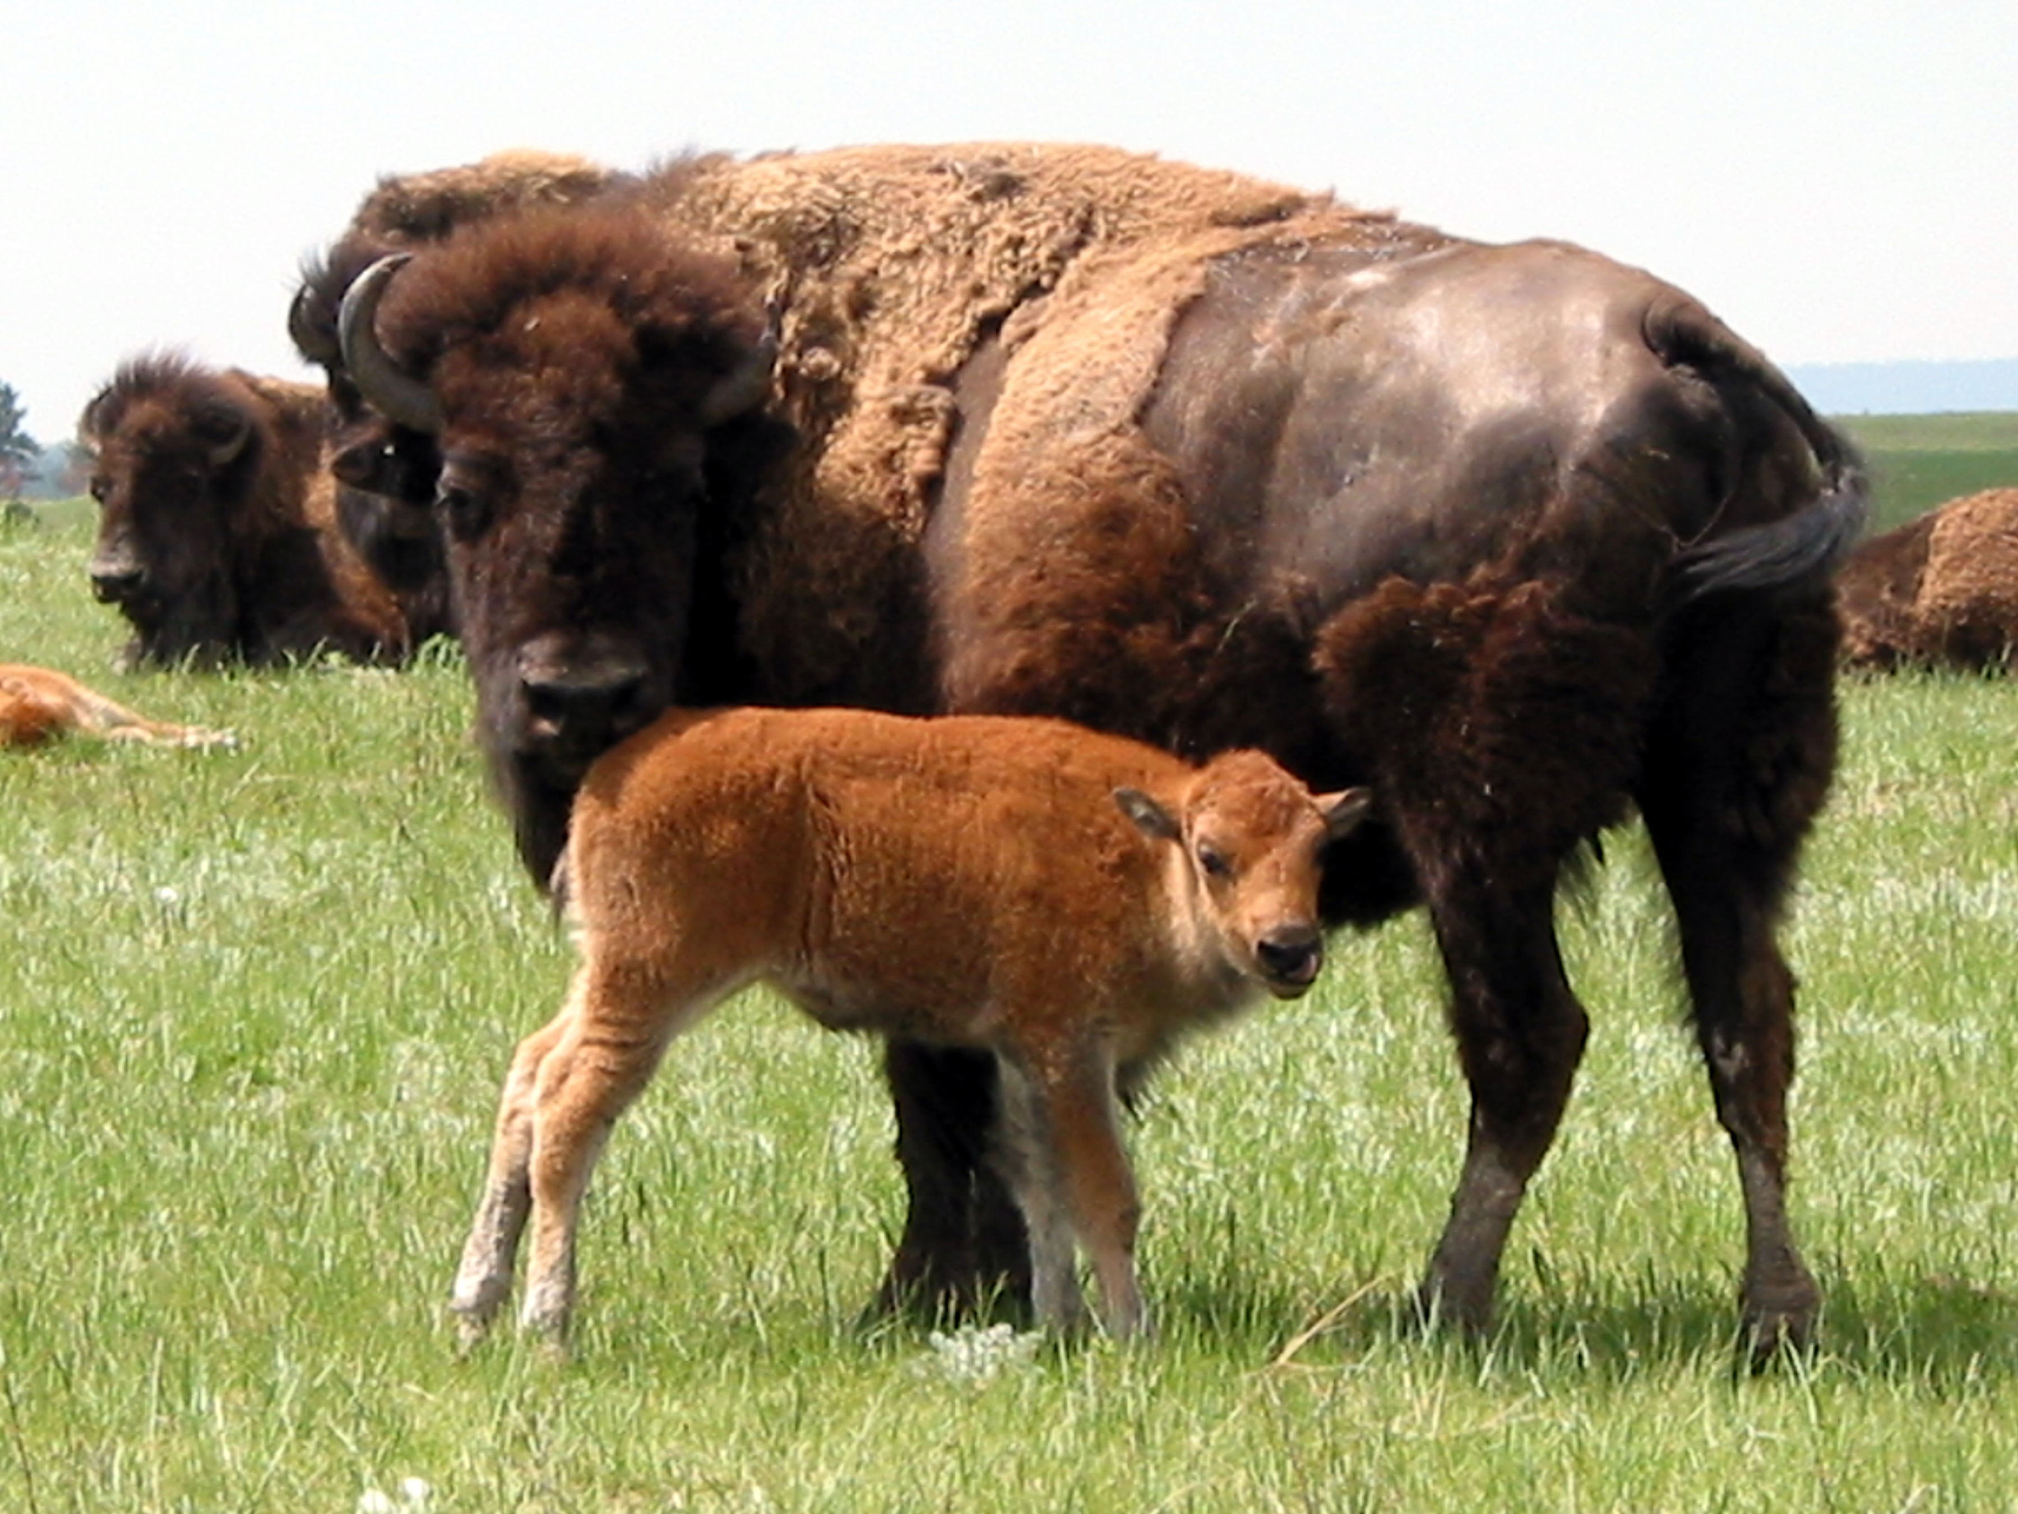

Wind Cave National Park from Rankin Ridge, the park's highest point.

### Image

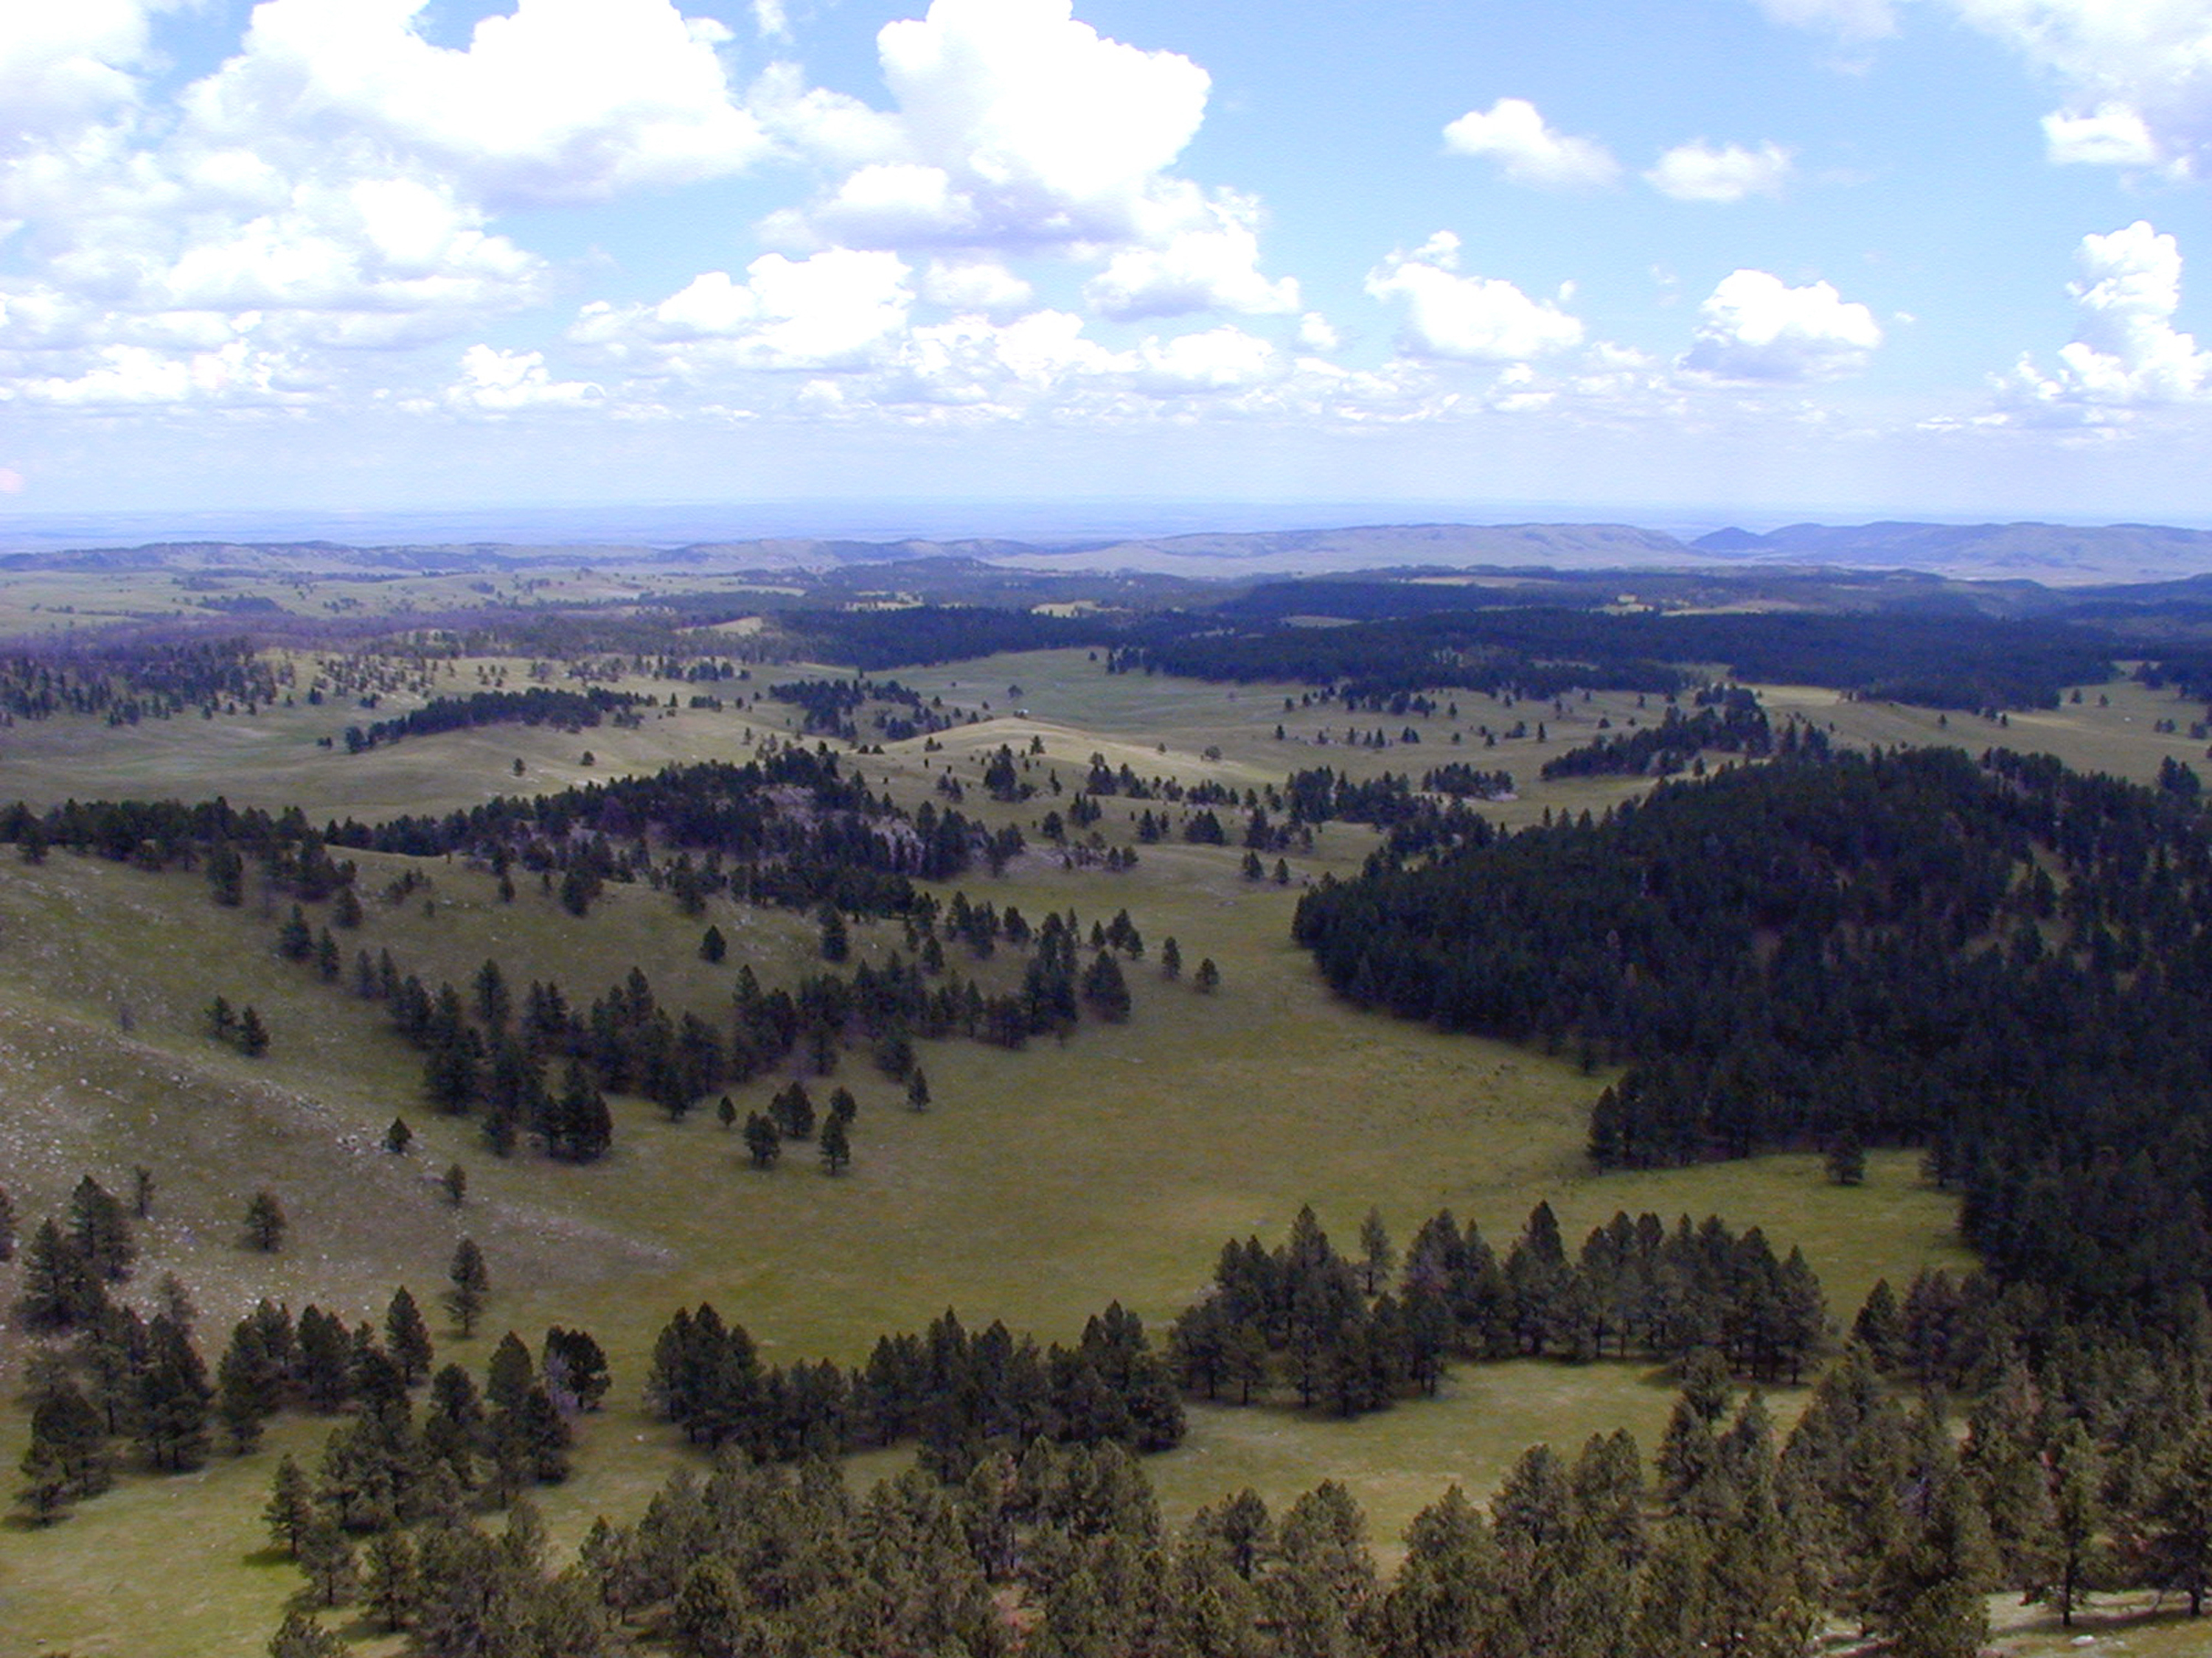

Delicate fins of boxwork, a rare cave feature, in Elk's Room, Wind Cave.

### Image

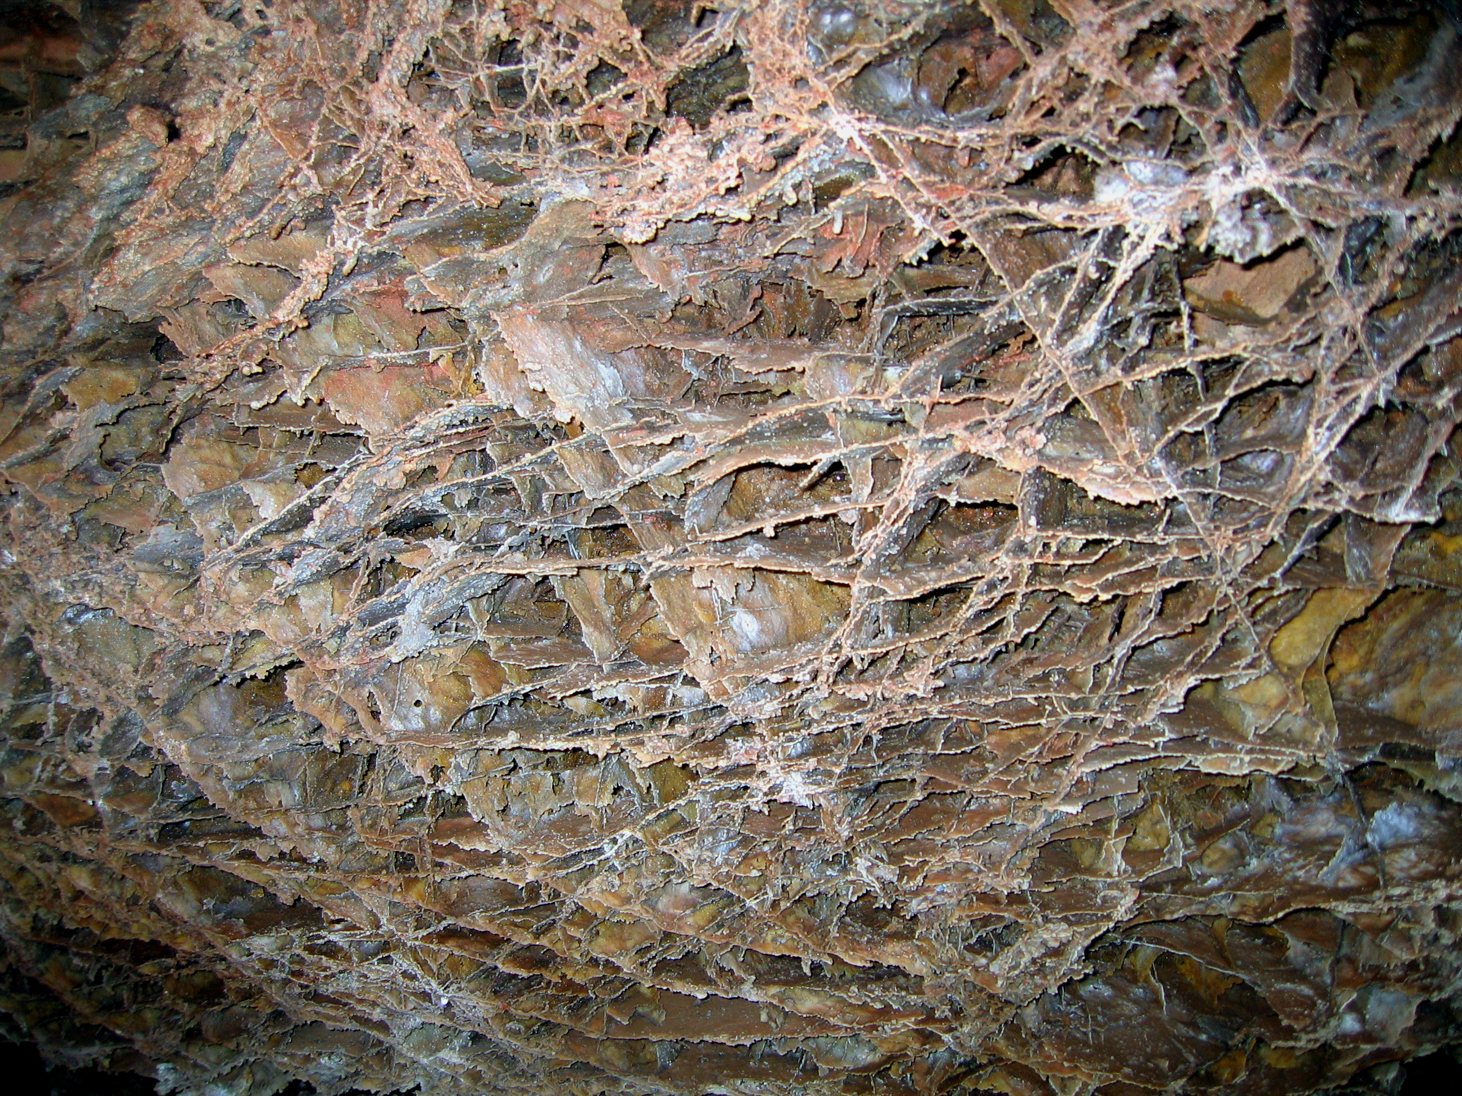

Each summer, the Wild Cave Tour offers the chance to get up close and personal with Wind Cave.

### Image

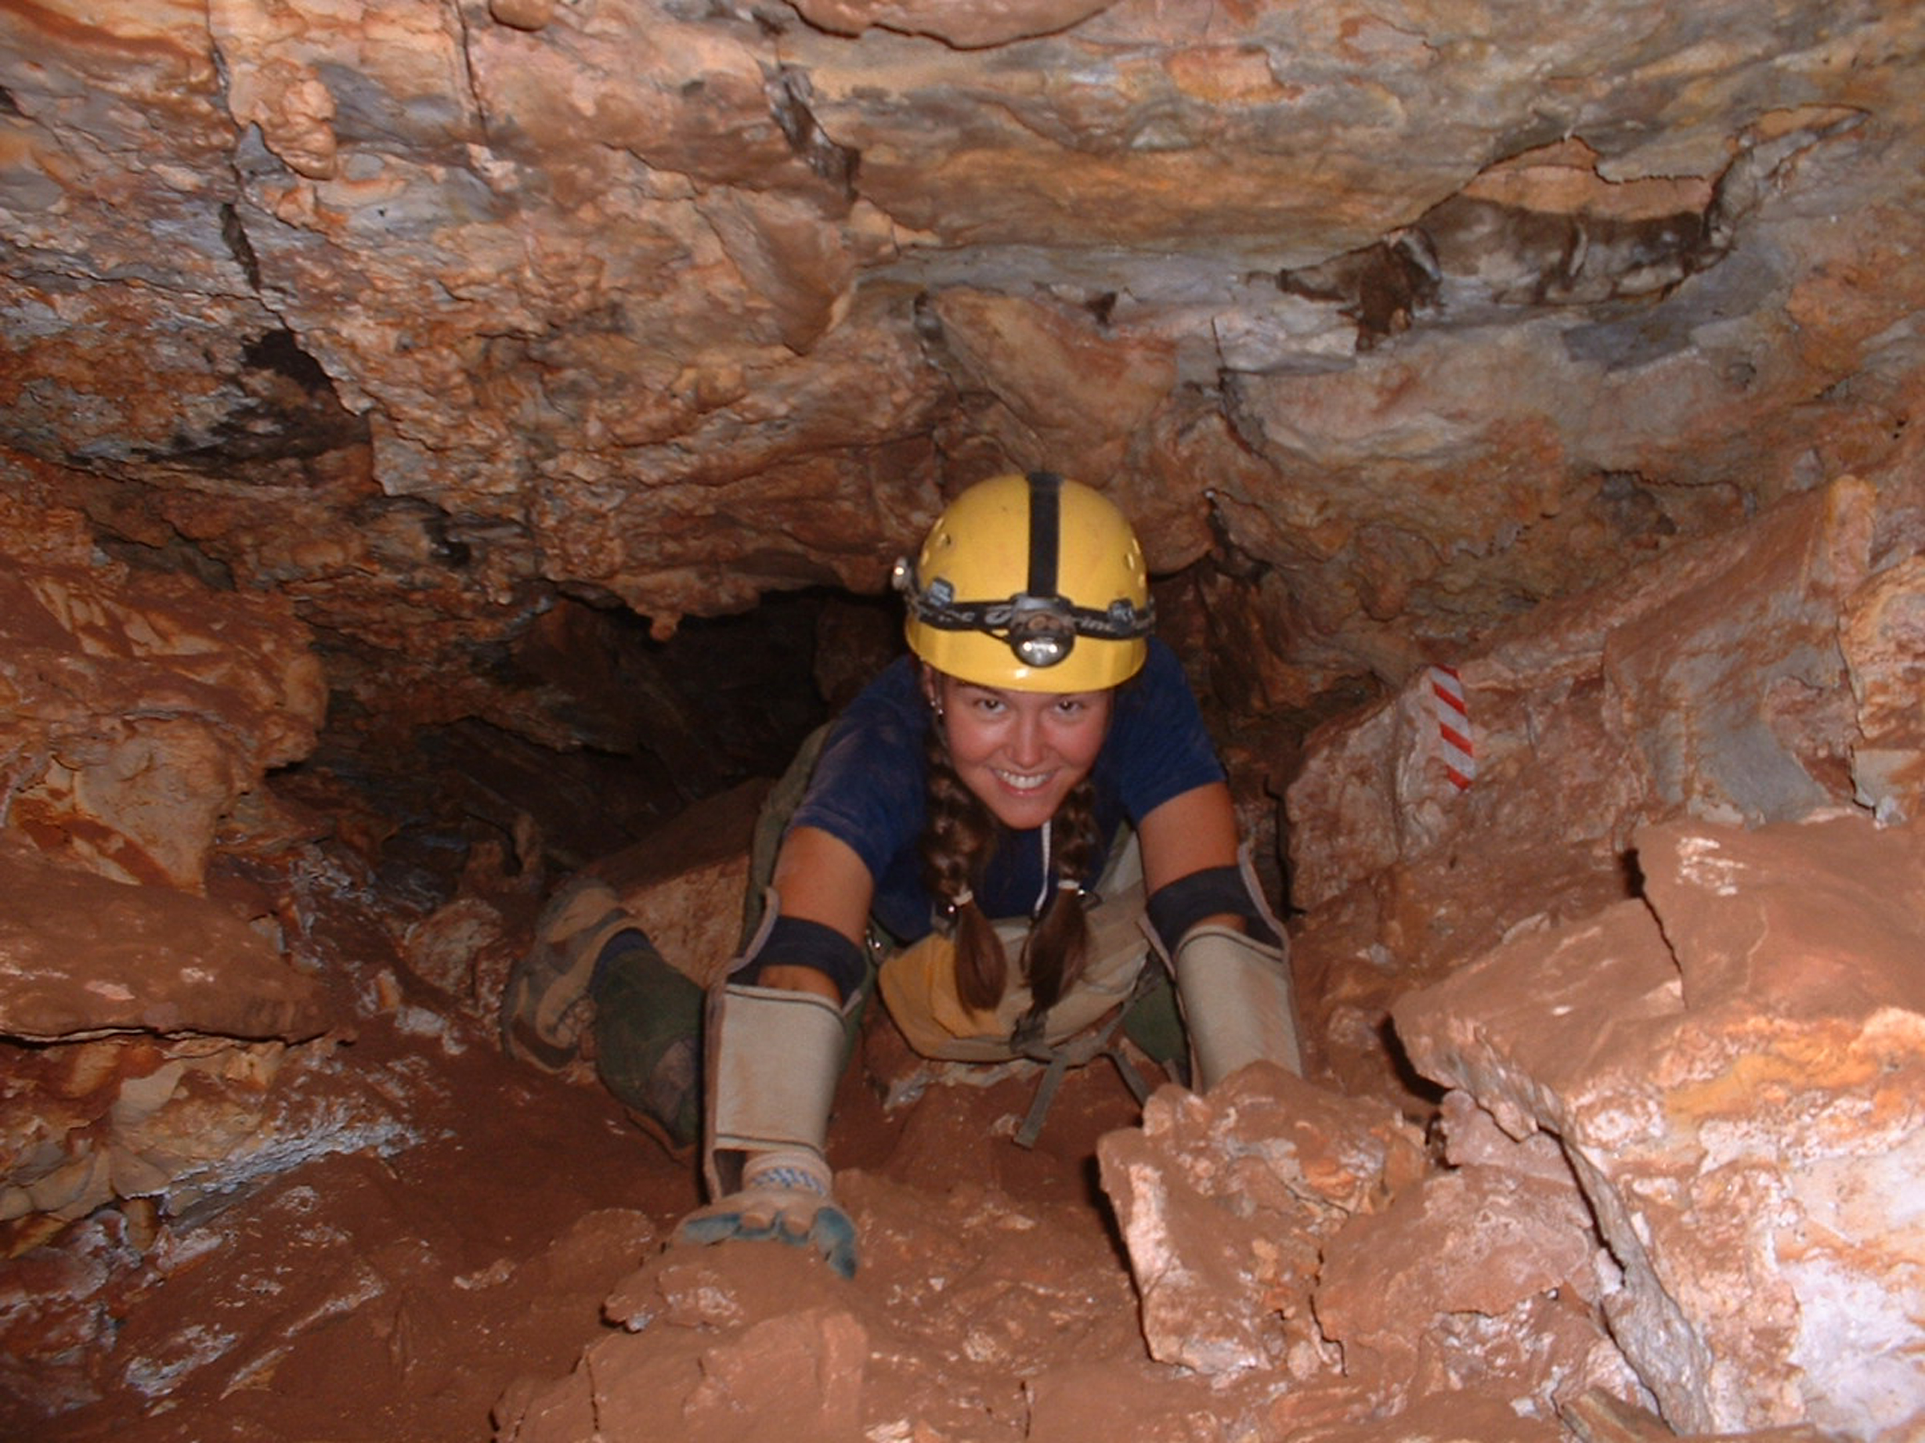

Prairie dog sightings are common throughout the park's prairies.

### Image

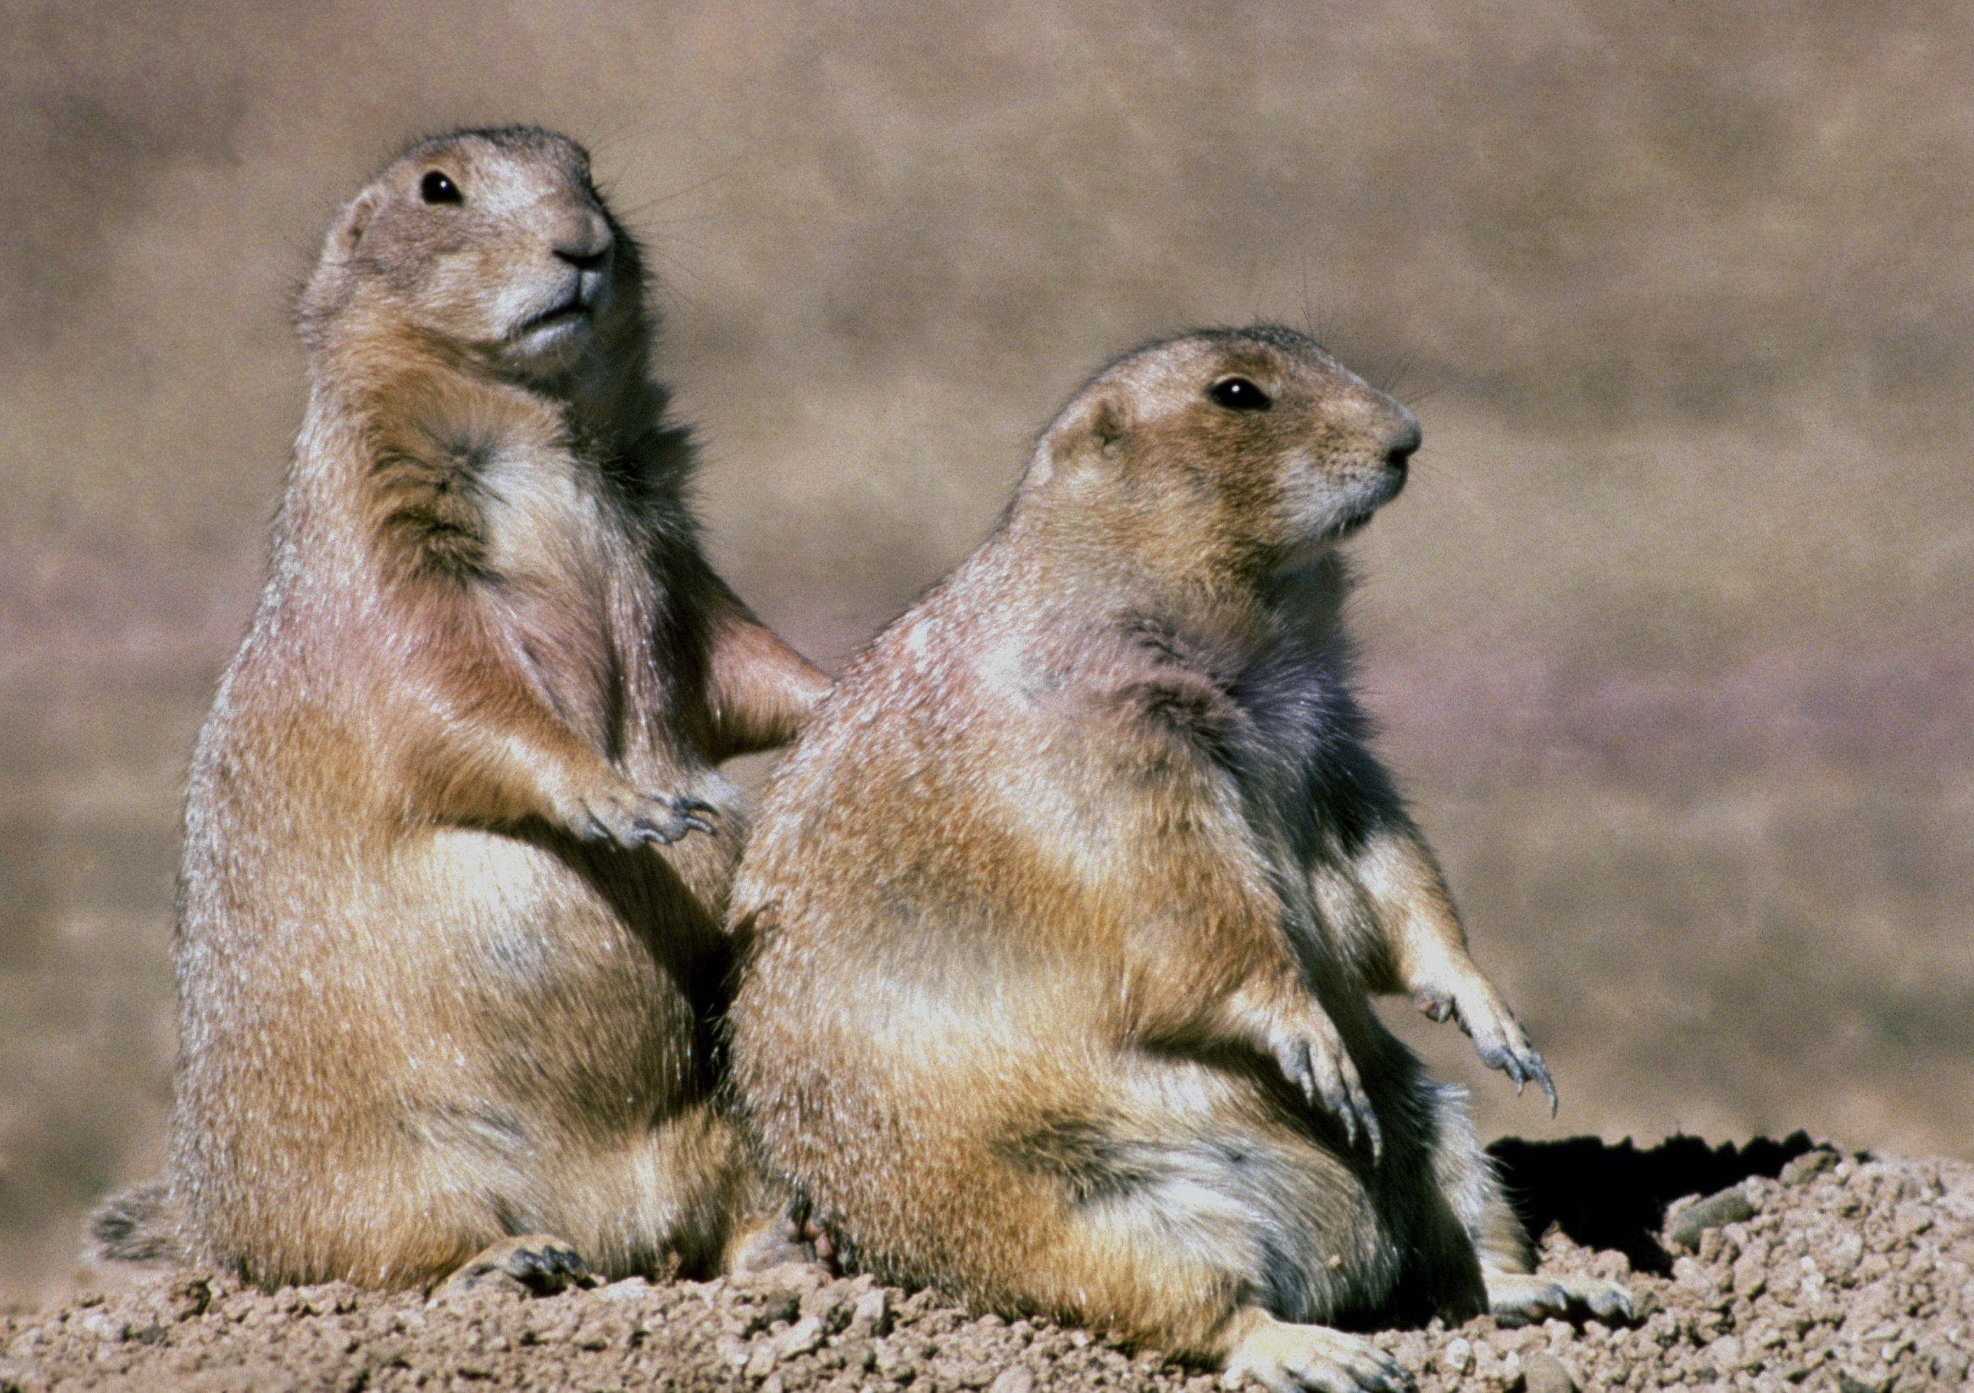

## Channel Islands National Park

Description: Channel Islands National Park encompasses five remarkable islands and their ocean environment, preserving and protecting a wealth of natural and cultural resources. Isolation over thousands of years has created unique animals, plants, and archeological resources found nowhere else on Earth and helped preserve a place where visitors can experience coastal southern California as it once was.

Activities: Birdwatching, Boat Tour, Camping, Fishing, Museum Exhibits, Off-Trail Permitted Hiking, Paddling, SCUBA Diving

Location: {'latitude': '33.98680093', 'longitude': '-119.9112735'}

contact info

### Address

1901 Spinnaker Drive  
CA  
93001

## Crater Lake National Park

Description: Crater Lake inspires awe. Native Americans witnessed its formation 7,700 years ago, when a violent eruption triggered the collapse of a tall peak. Scientists marvel at its purity: fed by rain and snow, it’s the deepest lake in the USA and one of the most pristine on earth. Artists, photographers, and sightseers gaze in wonder at its blue water and stunning setting atop the Cascade Mountain Range.

Activities: Auto and ATV, Boat Tour, Bus/Shuttle Guided Tour, Dining, Junior Ranger Program, Shopping, Skiing, Snow Play, Snowshoeing

Location: {'latitude': '42.94065854', 'longitude': '-122.1338414'}

contact info

### Address

Crater Lake National Park  
1 Sager Building  
OR  
97604

Looking at Crater Lake and Wizard Island from Discovery Point

### Image

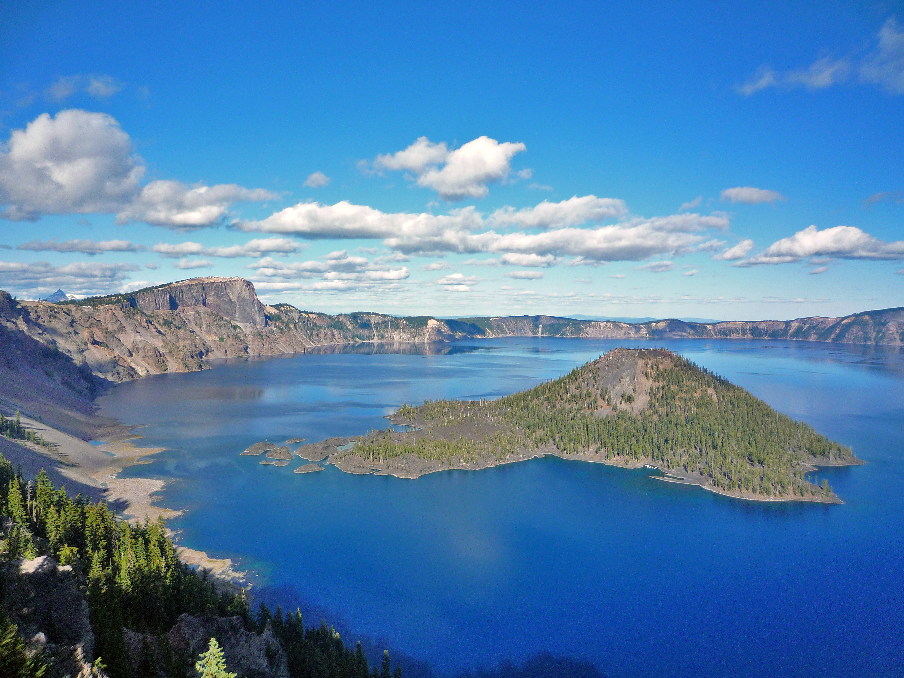

A view from Garfield Peak along the rim of Crater Lake

### Image

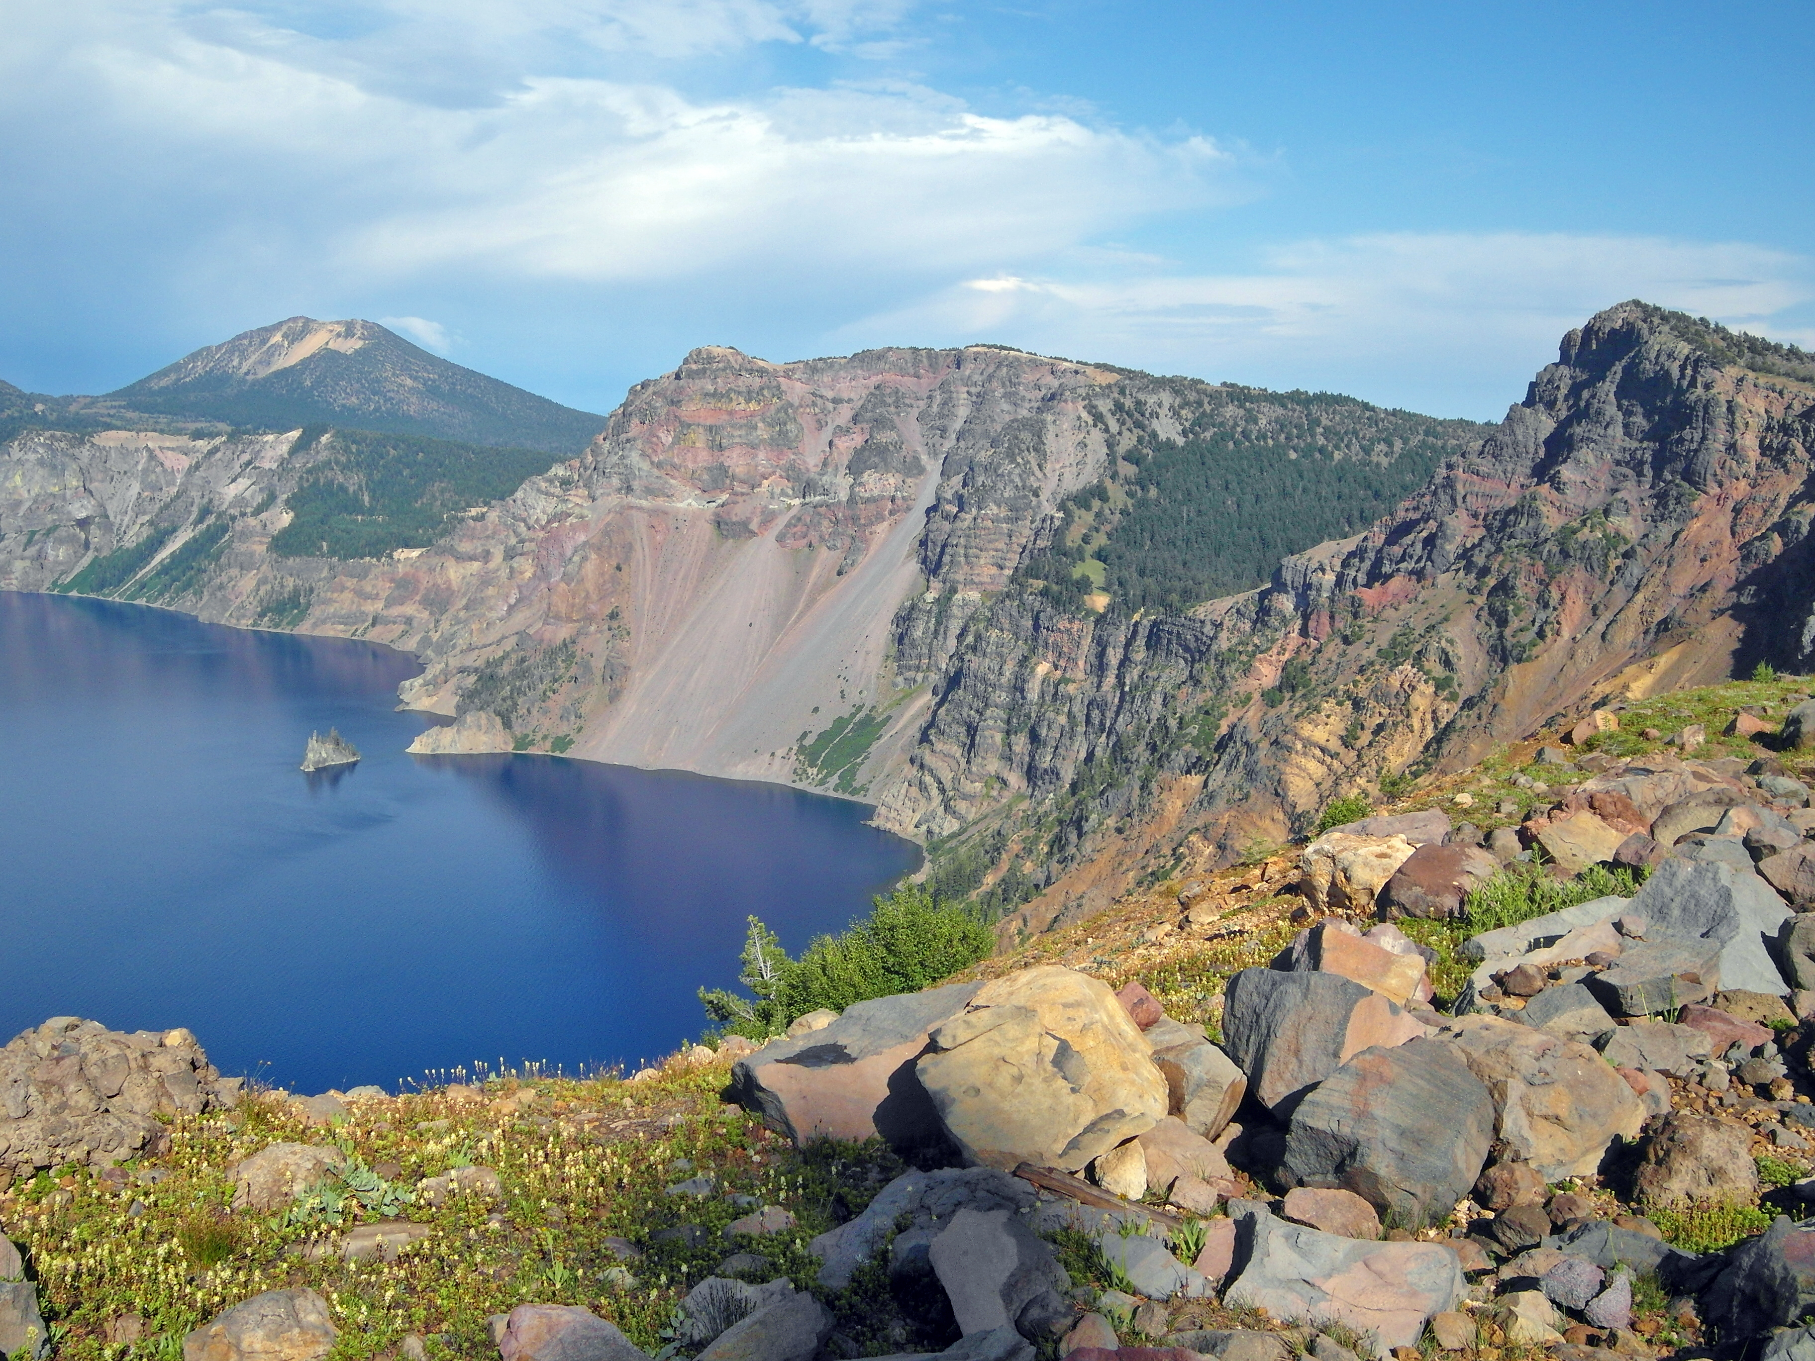

A view across Crater Lake from the lakeshore

### Image

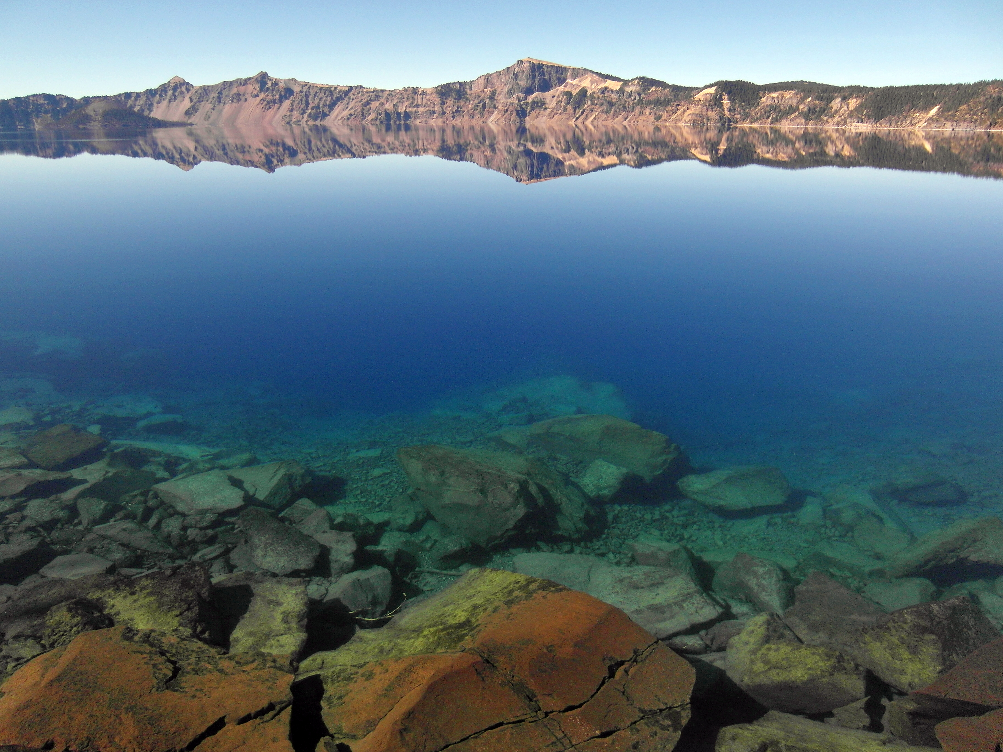

A view of the caldera from Mt. Scott, the highest point in Crater Lake National Park

### Image

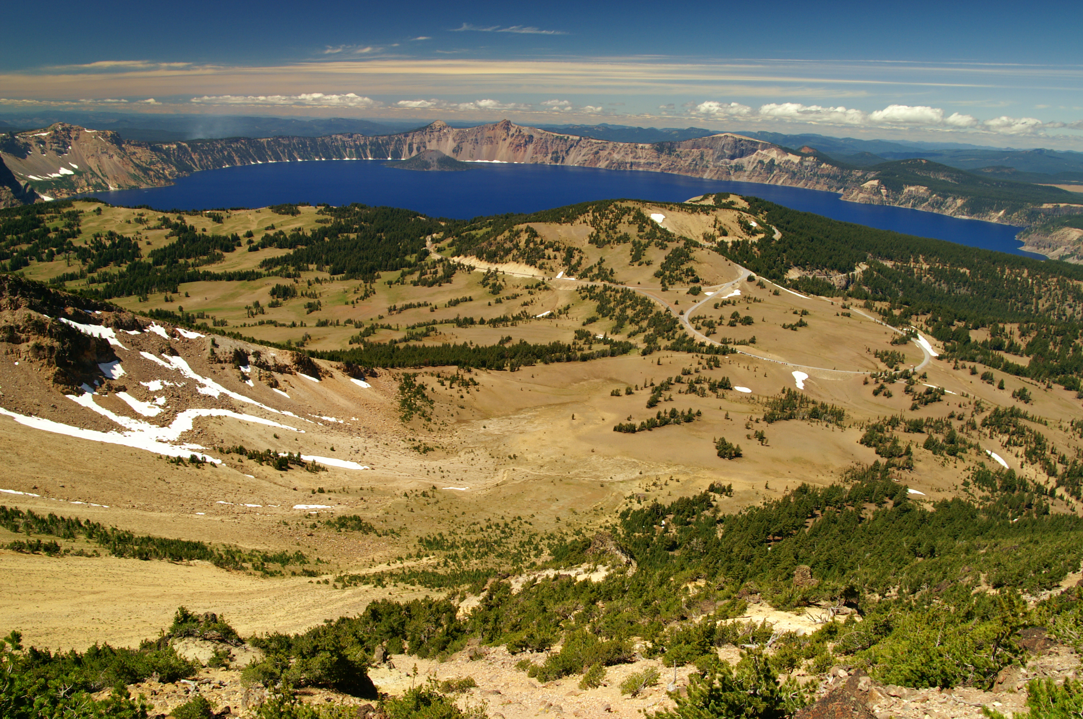

Water flowing over Vidae Falls

### Image

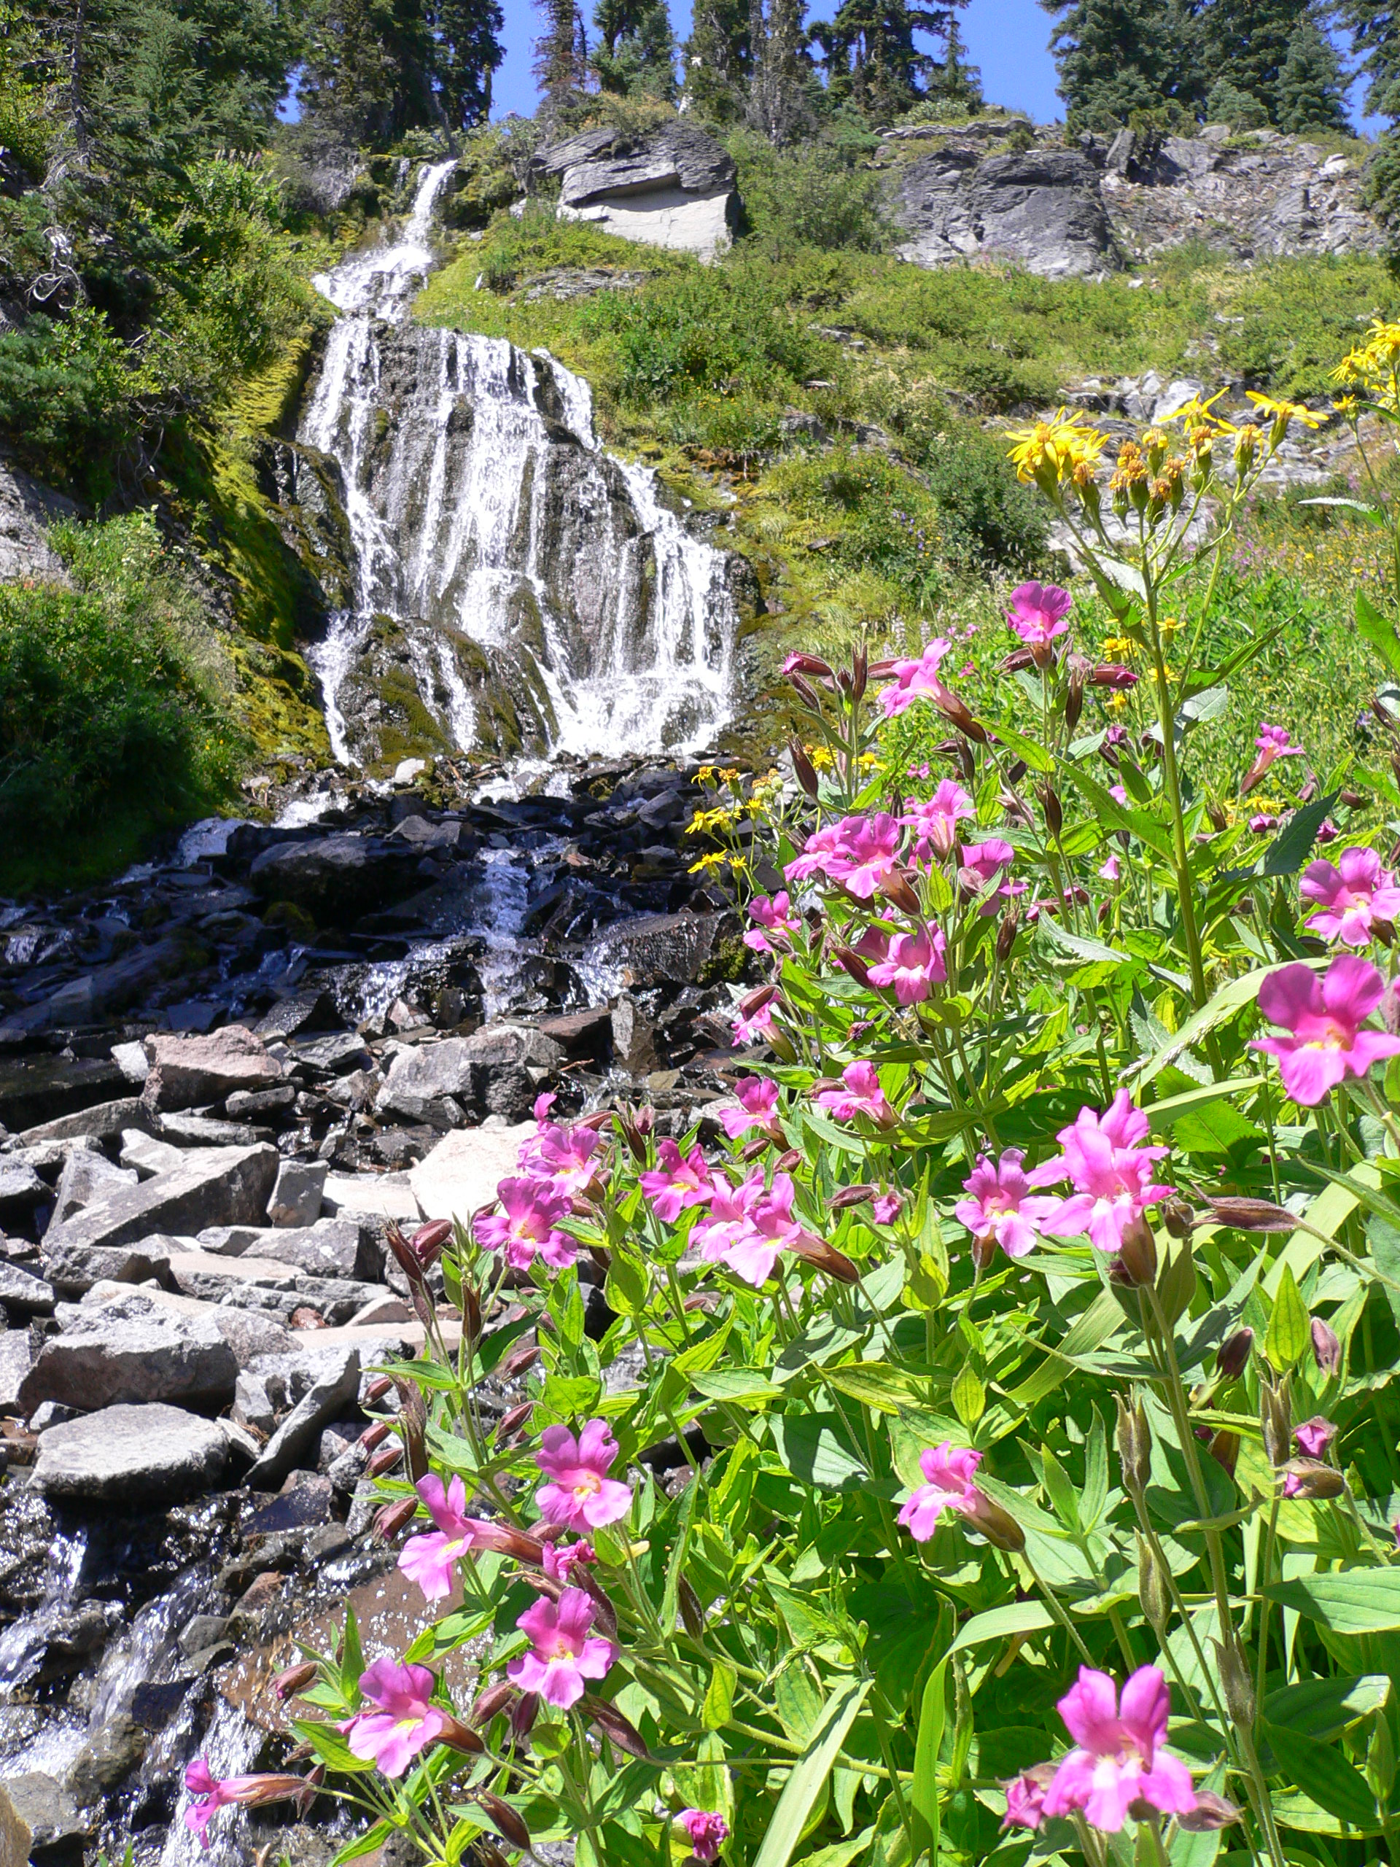

Wildflowers along the Wizard Island Summit Trail

### Image

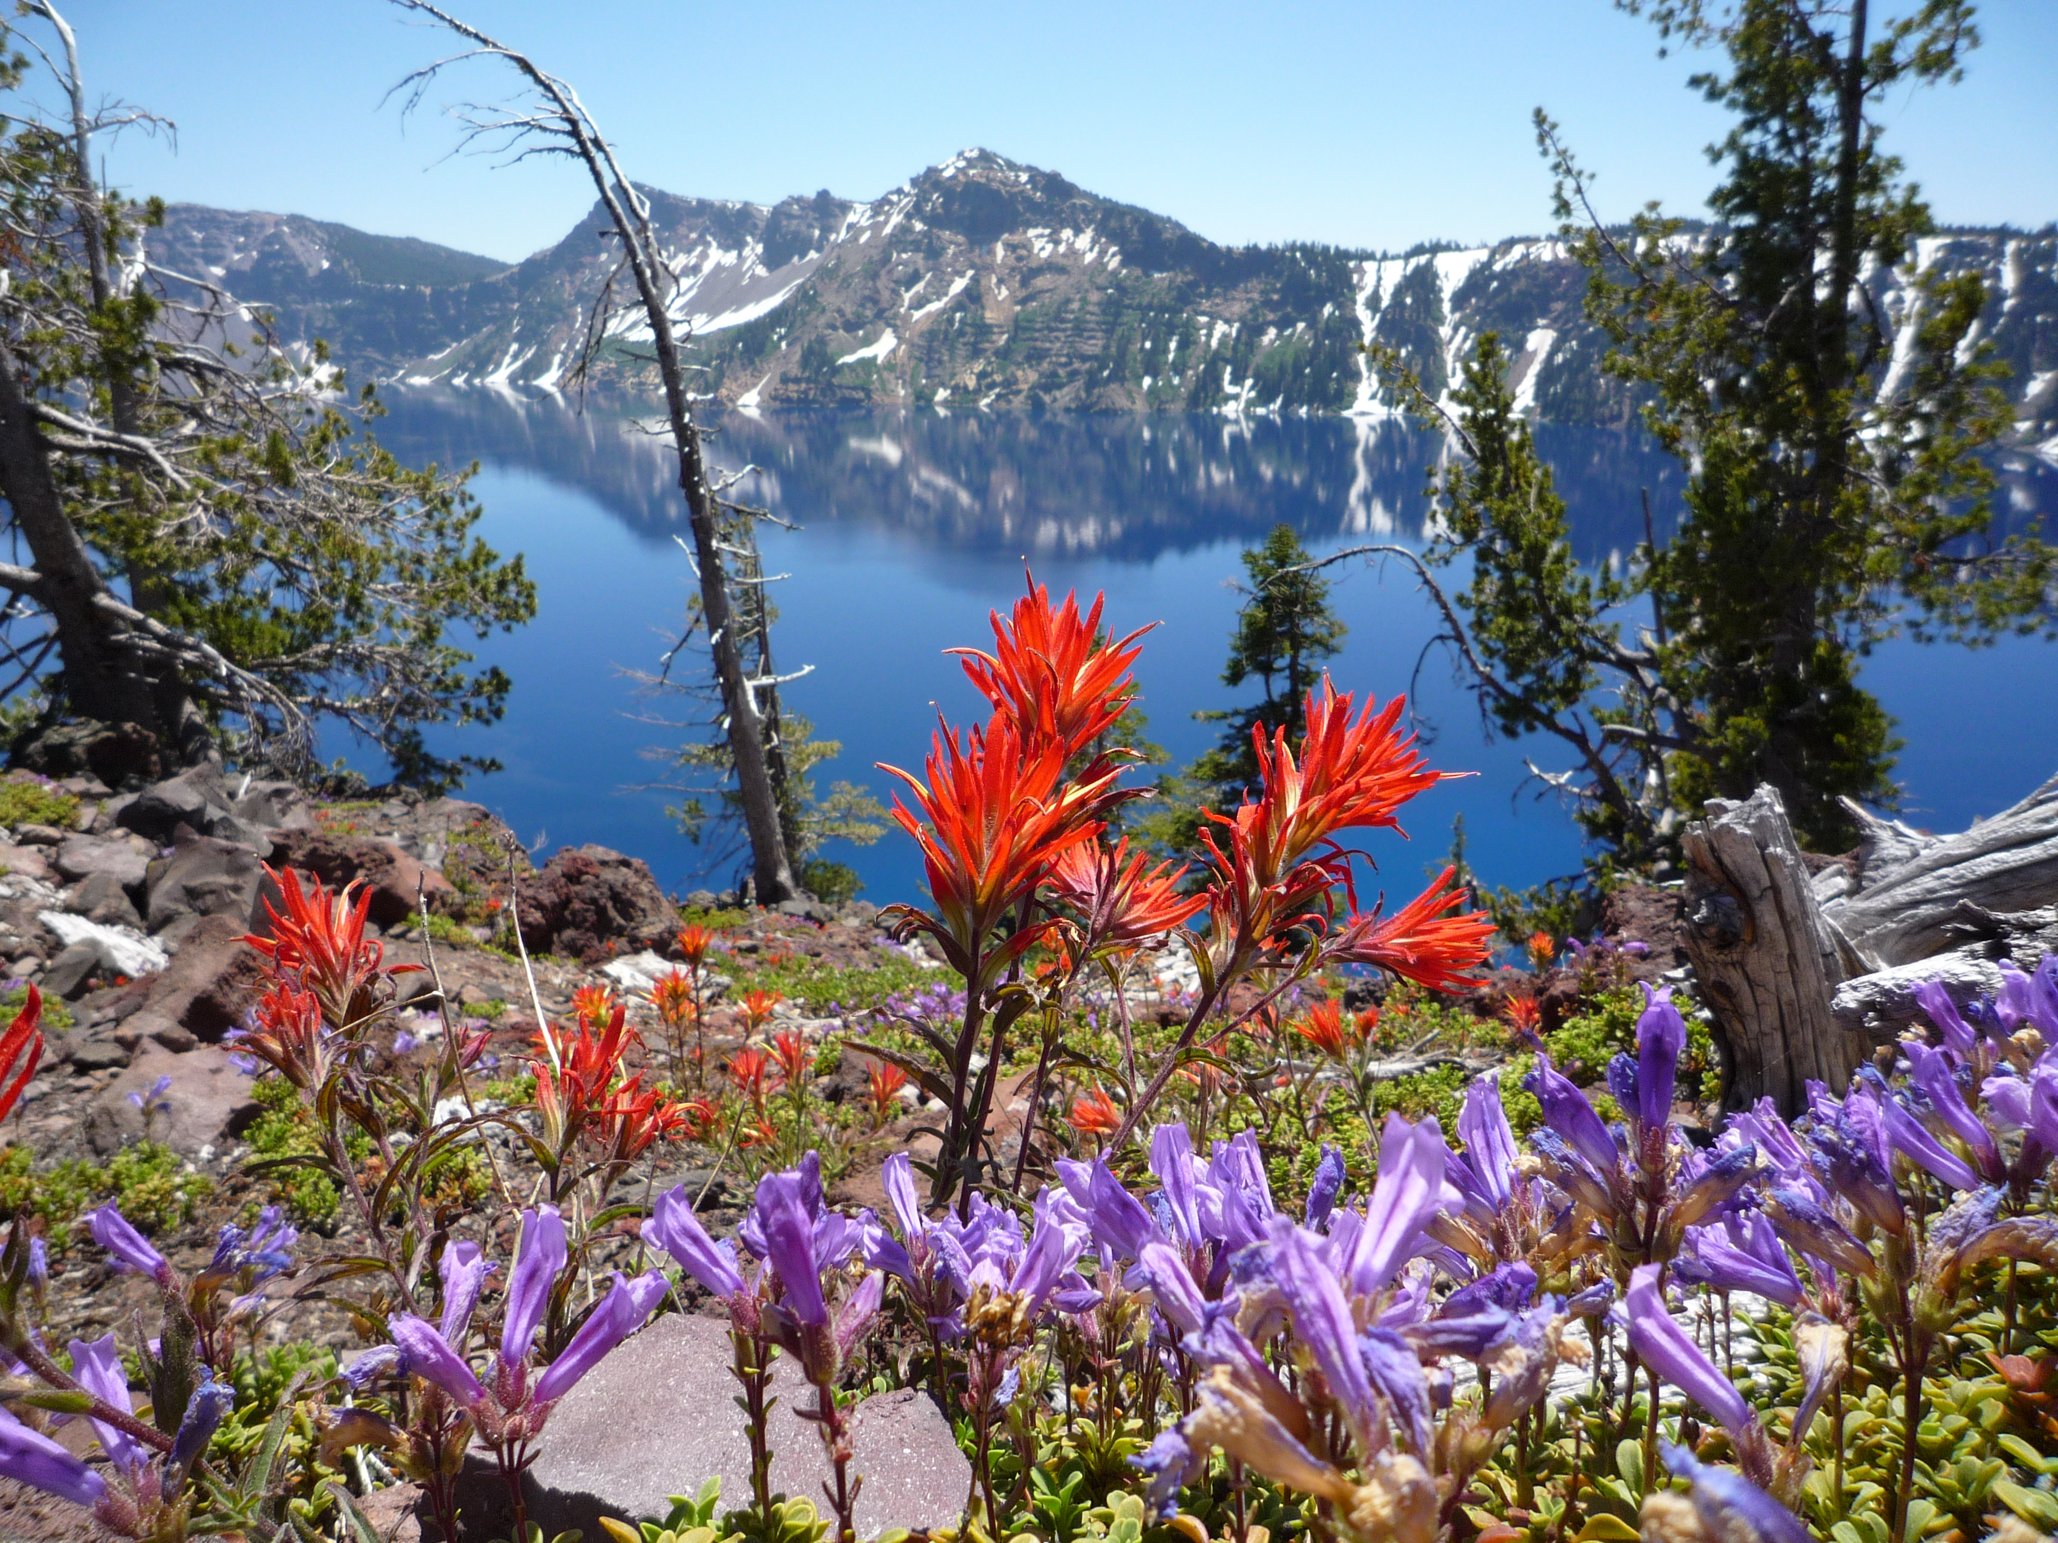

## Grand Canyon National Park

Description: Located in Arizona, Grand Canyon National Park encompasses 277 miles (446 km) of the Colorado River and adjacent uplands. The immense Grand Canyon is a mile (1.6 km) deep, and up to 18 miles (29 km) wide. Layered bands of colorful rock reveal millions of years of geologic history with unmatched vistas from the rim. The South Rim is open 24 hours. The North Rim is Closed for the Winter.

Activities: Arts and Culture, Food, Guided Tours, Park Film, Shopping

Location: {'latitude': '36.0001165336', 'longitude': '-112.121516363'}

contact info

### Address

20 South Entrance Road  
AZ  
86023

People come from all over the world to view Grand Canyon's sunset

### Image



A popular outdoor site for weddings and receptions, Cape Royal Amphitheater is located 23 miles (37 km) from the North Rim developed area.

### Image

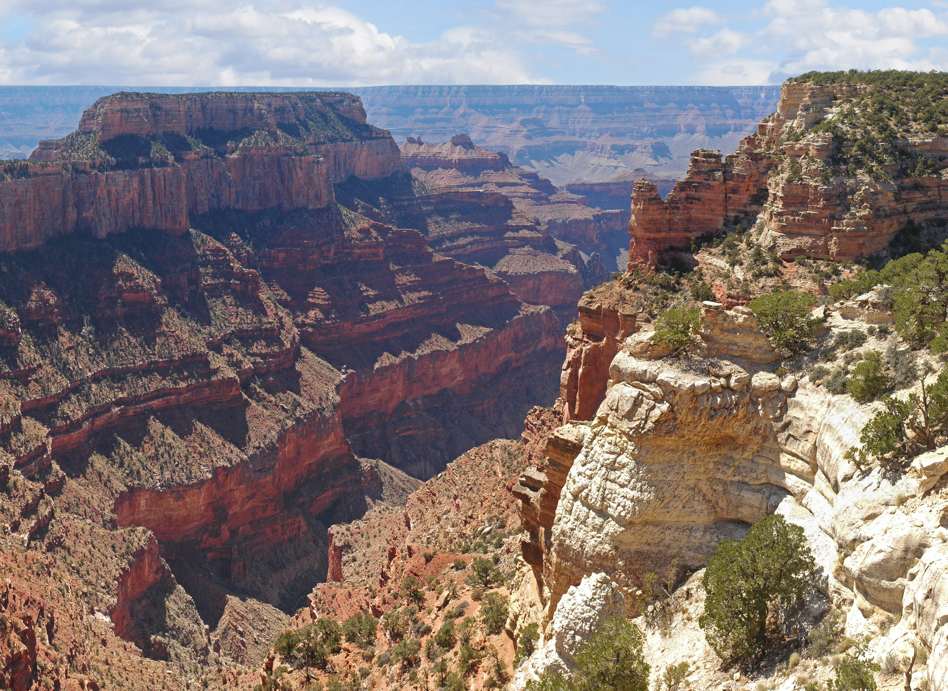

The Watchtower is located at Desert View, the eastern-most developed area on the South Rim of Grand Canyon National Park.

### Image

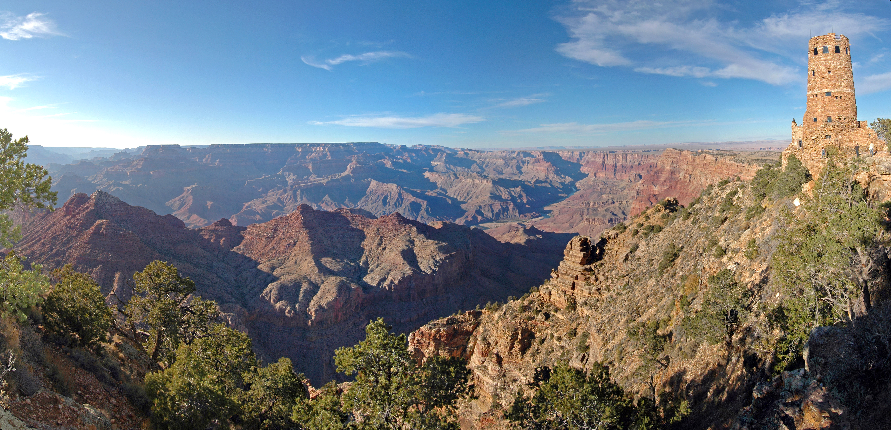

A view down the Colorado river from Nankoweap in Marble canyon.

### Image

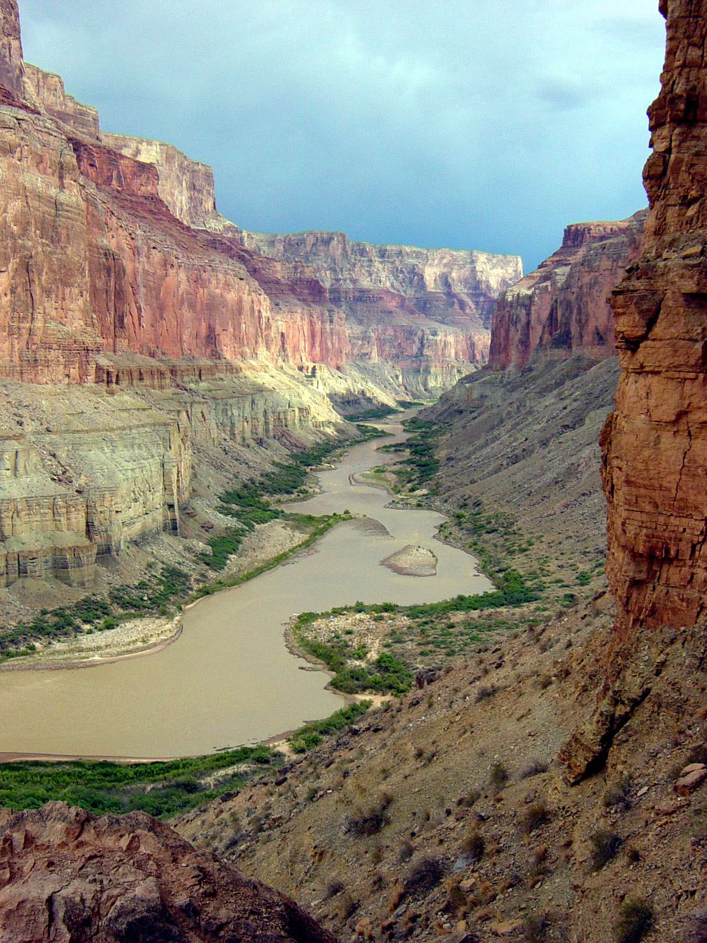

## Bryce Canyon National Park

Description: Hoodoos (irregular columns of rock) exist on every continent, but here is the largest concentration found anywhere on Earth. Situated along a high plateau at the top of the Grand Staircase, the park's high elevations include numerous life communities, fantastic dark skies, and geological wonders that defy description.

Activities: Astronomy, Backcountry Hiking, Food, Group Camping, Museum Exhibits, Park Film, RV Camping, Road Biking, Stargazing

Location: {'latitude': '37.58399144', 'longitude': '-112.1826689'}

contact info

### Address

Highway 63  
Bryce Canyon National Park  
UT  
84764

Viewpoints of the iconic Bryce Amphitheater are located along the first 3 miles of the park road and are a popular destination at sunrise.

### Image

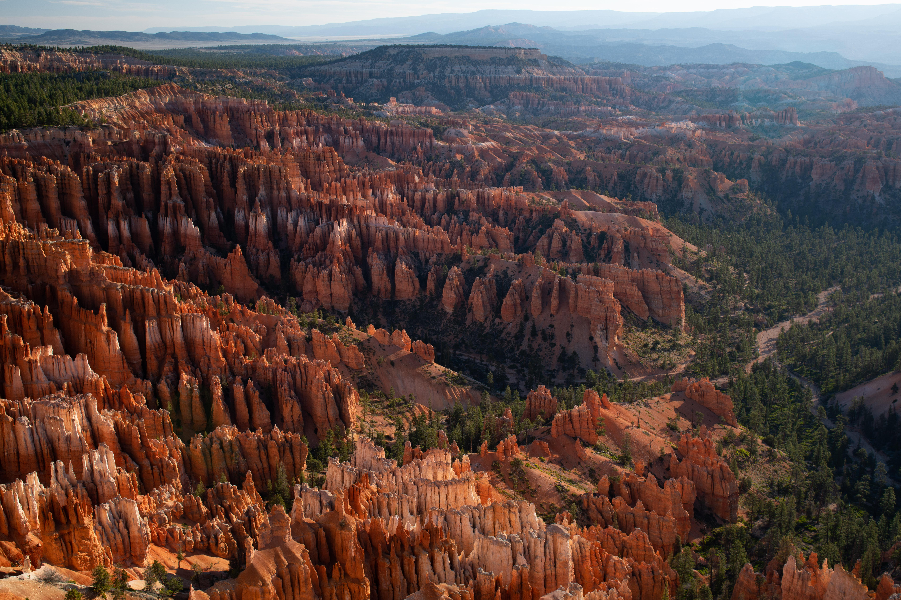

Here at 8,000' (2438 m) winter comes early and stays late. Snow transforms the landscape and requires seasonal closures in some areas and trails.

### Image

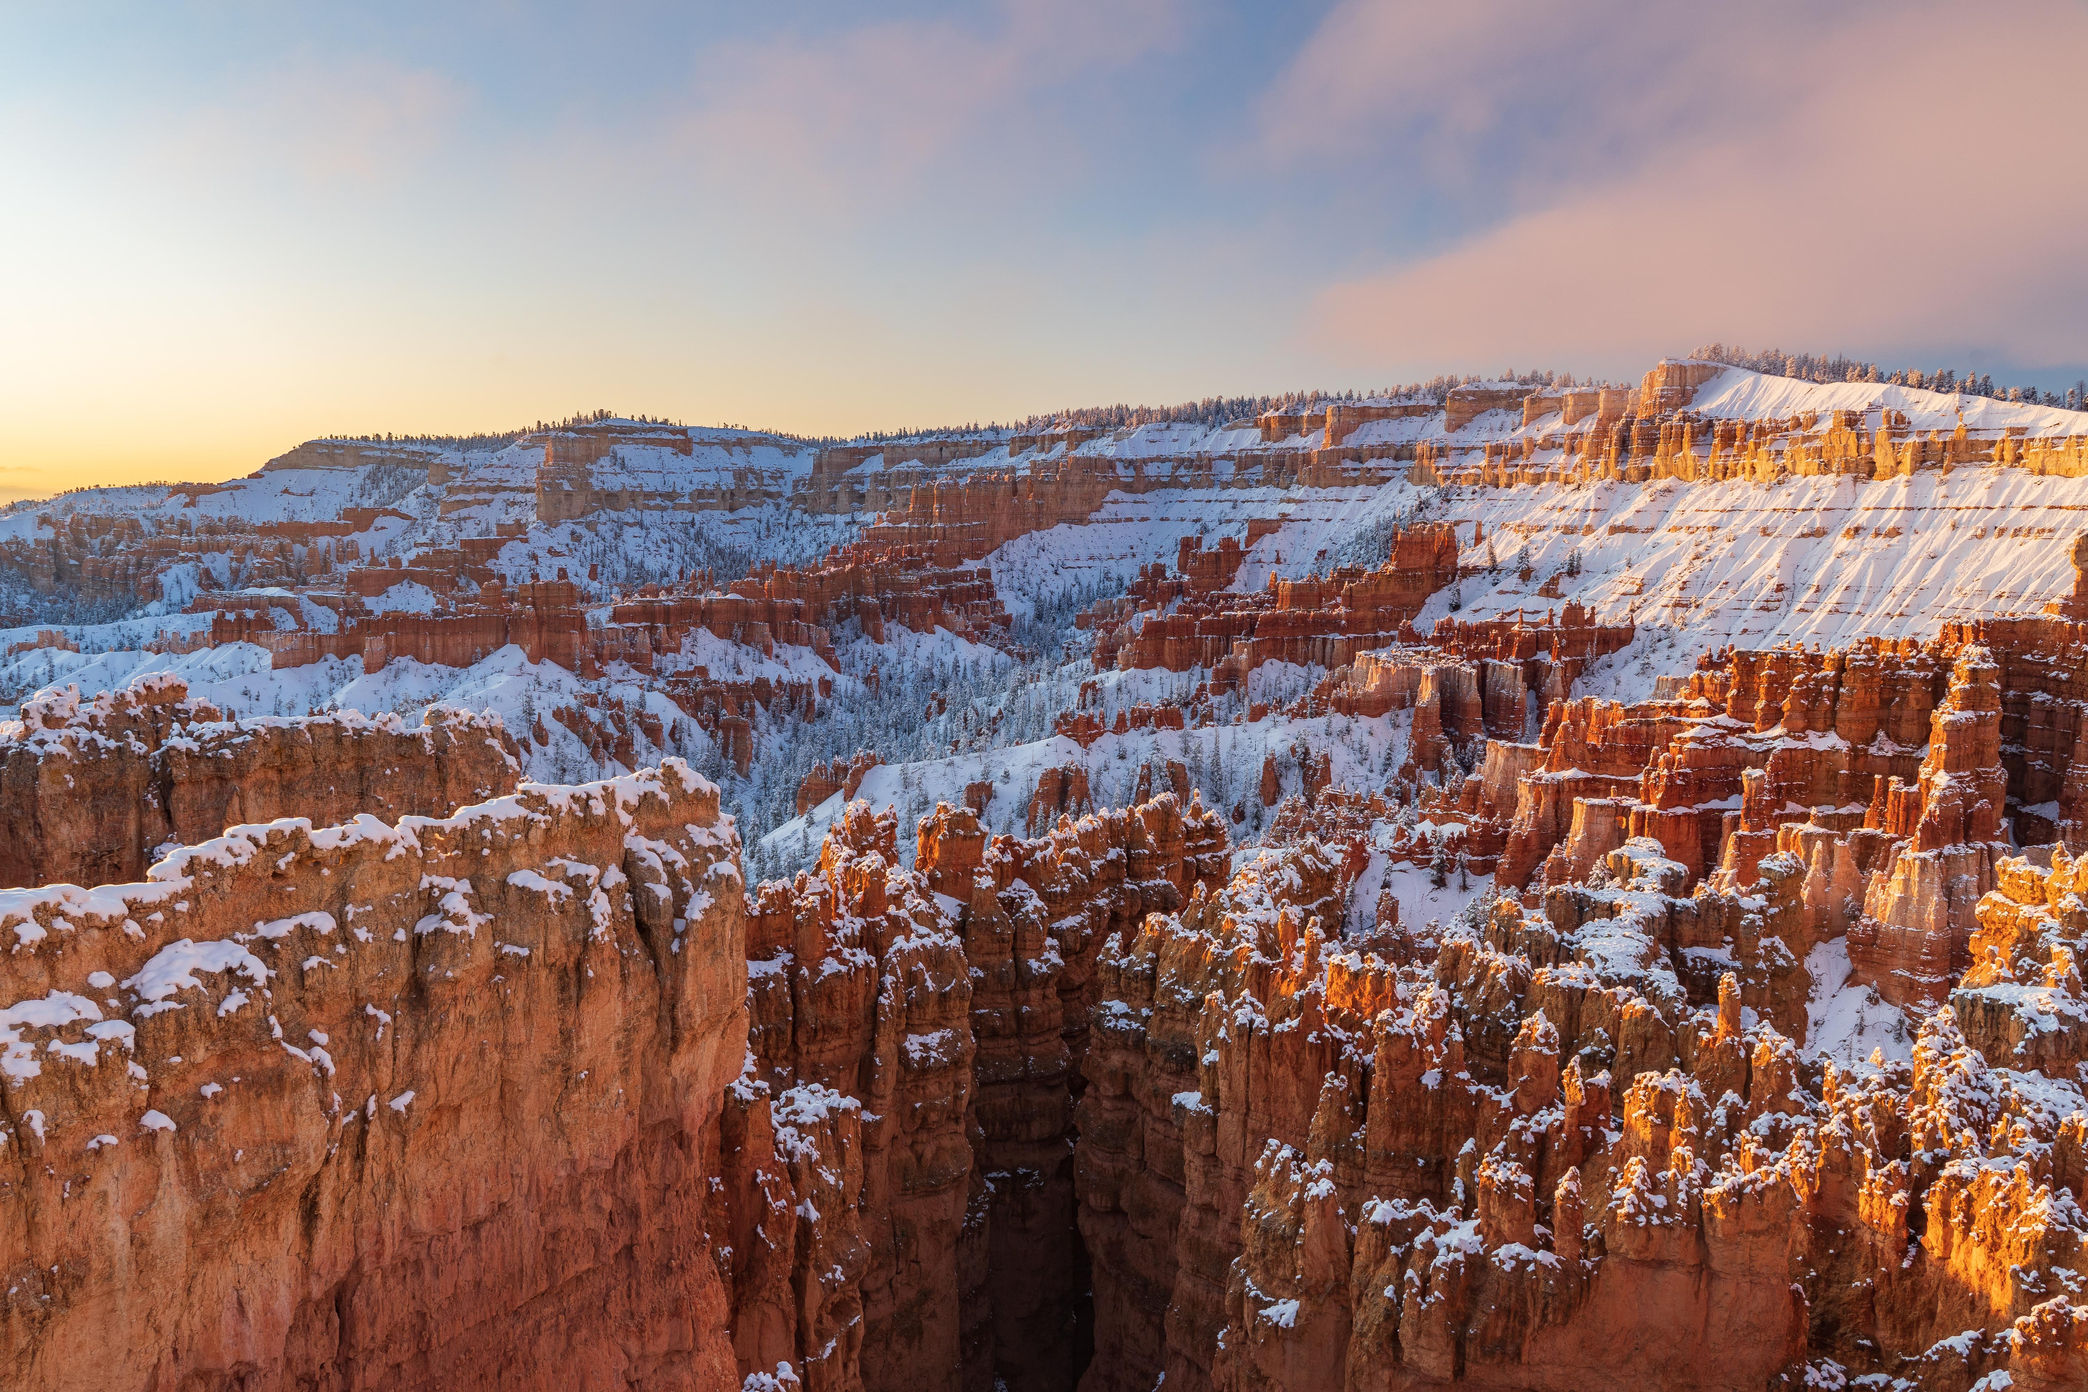

More strenuous trails below the rim provide up-close views of the hoodoo rock spires, while easier walks along the rim give perspective from above.

### Image

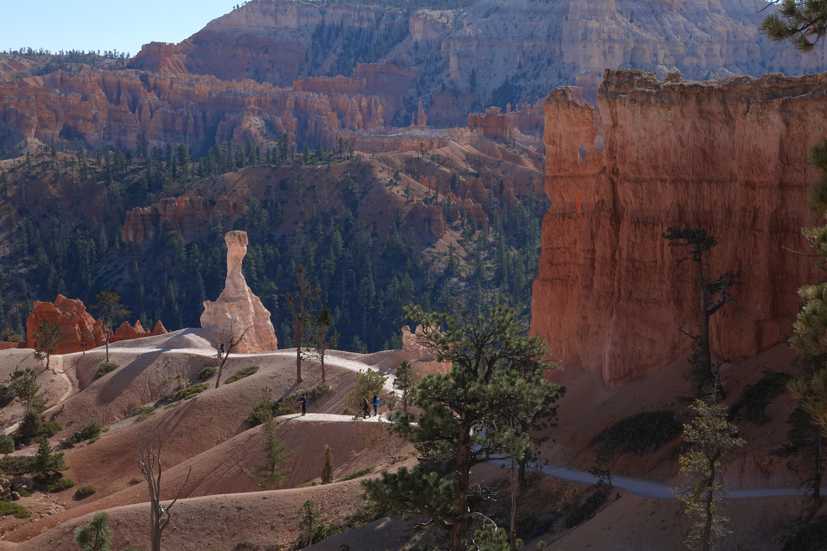

The park's highest elevations at its southern end and backcountry areas provide views of over 100 miles (161 km) atop high steep cliffs.

### Image

